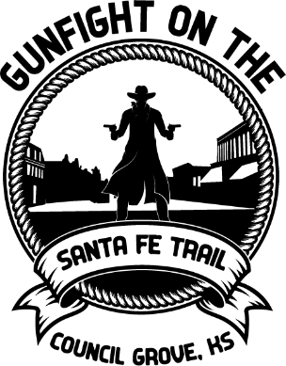
Madonna Trudge

September 3, 2022

Council Grove, KS
$20 registration fee

Name_________________________________________________
Address________________________________________________
Email__________________________________________________
Telephone Number_______________________________________
DAR Madonna Award - $250
Most like the pioneer woman represented by the Madonna Statue
​
DAR Best Attitude - $150
Best display of determined/stoic attitude, as represented by our pioneer ancestors
​
DAR Best Effort - $100 When life's challenges are huge and things don't go right, this woman perseveres. Her life depends on it!

All women entering must be wearing a long dress,
in honor of the Madonna of the Trail.

9:30 a.m. – Any guns used in the Madonna Trudge are to be safety checked at the statue.
​
Send Check to:
Heart of the Flint Hills Chapter
PO Box 45, Council Grove, KS 66846

For more information on Council Grove Santa Fe Trail 200 events, visit https://www.santafetrail200.com or email sft200cg@gmail.com

